**LINUX COMMANDS**

**07/3/22**

**1)pwd:** It will show the path where u allotted



**2) mkdir**: It is used to create the new Directory



**3)rmdir:** It is used to remove directory



**4)ls:** It is used to show the list of files in particular directory

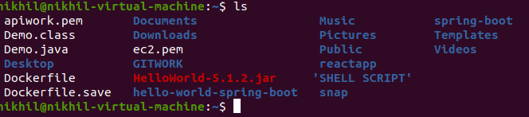

**5) cd**: change Directory from one directory to another Directory



**6)touch:** It is used to create the empty file

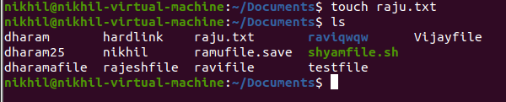

**7)cat:** It is used to display the particular file





**8)rm:** It is used to remove the file

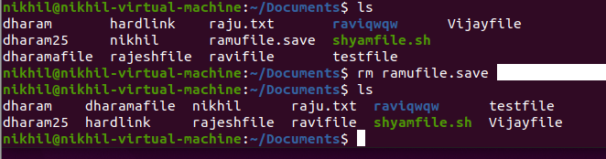

**9)cp**: It is used to copy the file

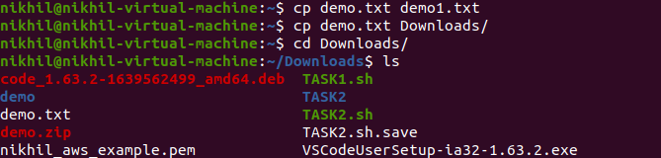

**10)mv:** It is used the move the file or directory

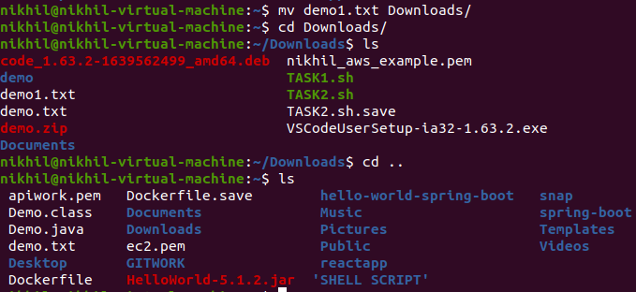

**11)rename command:** It is used to rename the file

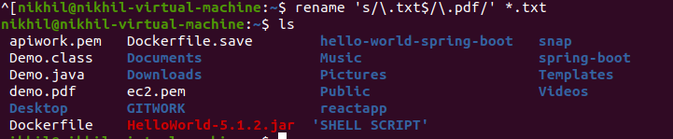

**12)head:** It is used to display the first 10 lines in the file

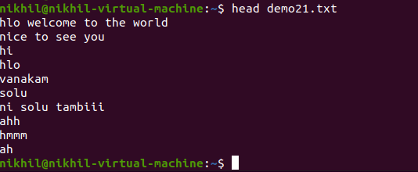

**13)tail**: It is used to display the last lines in the file as same as head visversa.

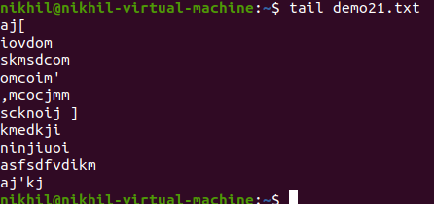

**14)tac command:** It is similar as cat it displays from last line to first

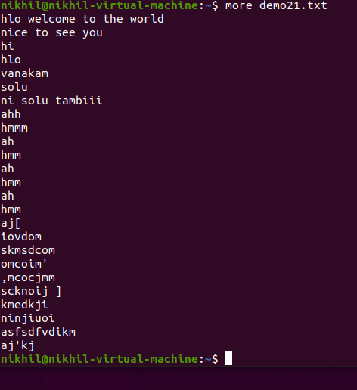

**15)more:** It work same as the cat once it contains the large file means it will be show at a time



**16)less:** It is display in another file directly



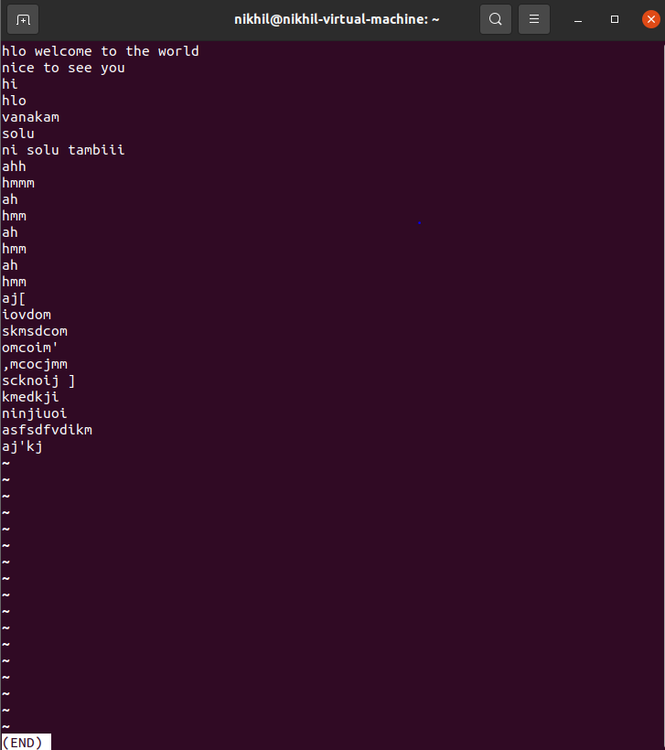

**17)su command**: It is provided the administration access to another user.

**18)id**: It display the user ID and group ID

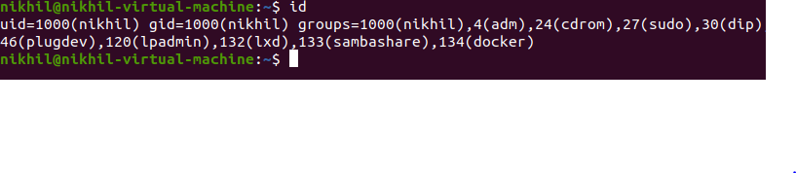

**19)useradd:** It is used add or remove

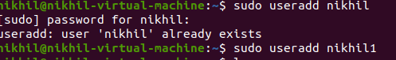

**20)** **passwd Command**: The passwd command is used to update the passwd

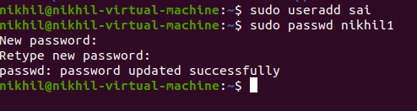

**21)groupadd Command:** It is used to create a user group

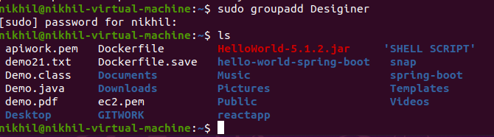

**22)cat Command**

The cat command is used to filter according cat or tac

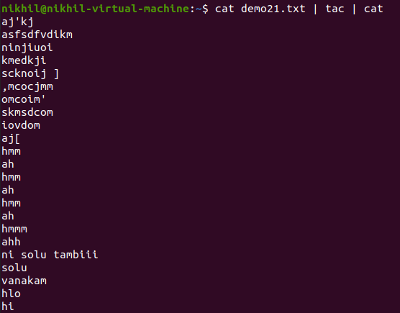

**23)cut command:** It is used to display your file according to the rows it will display whatever you assign it to.

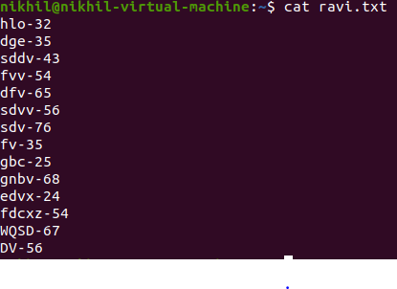

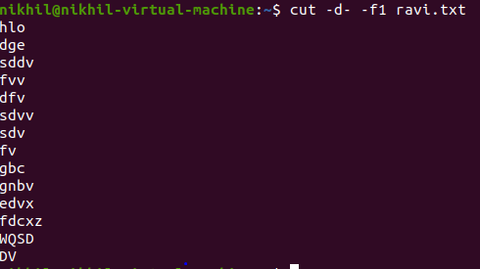

**24)grep:** It is used to find the content of the file

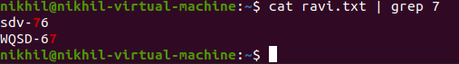

**25)comm command The** [**'comm'**](https://www.javatpoint.com/linux-comm) **command is used to compare two files or streams. By default, it displays three columns, first displays non-matching items of the first file, second indicates the non-matching item of the second file, and the third column displays the matching items of both files.**

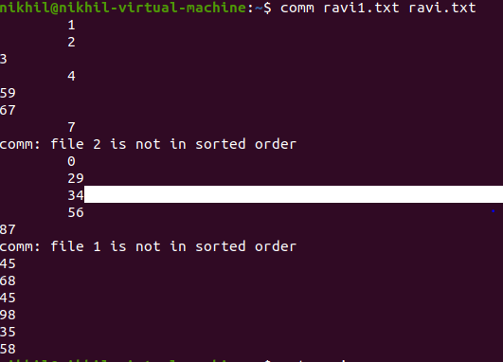

**26)sed command:** It assign old file into the new file

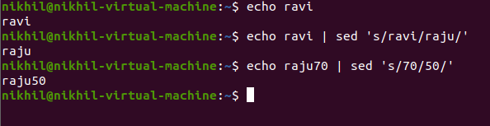

**27)tee command:** It assign like similar as cat file at a time

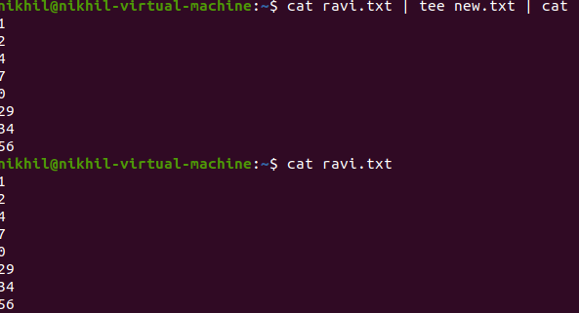

**28)tr command:** It is used to translate the particular text lower case to upper case

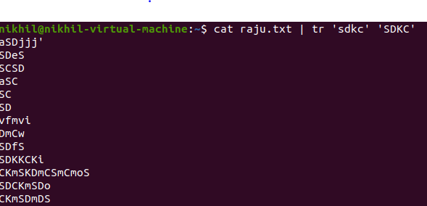

**29)uniq command:** It will used to perform the sorted list occur only once

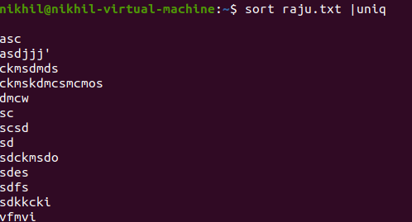

**30)wc command:** It is used to count the words of the character



**31)od command:** it is used to content of a file in different such as octal, ascii character

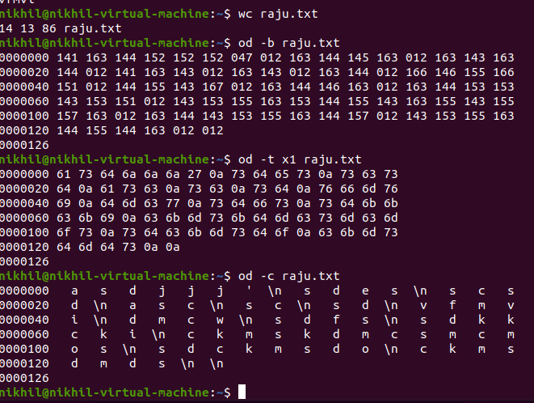

**32)sort command:** it is used in alphabetical order.

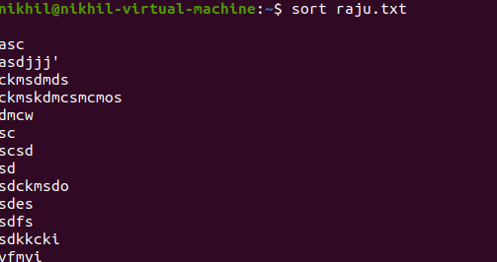

**33)gzip command** : It is used to gzip the file

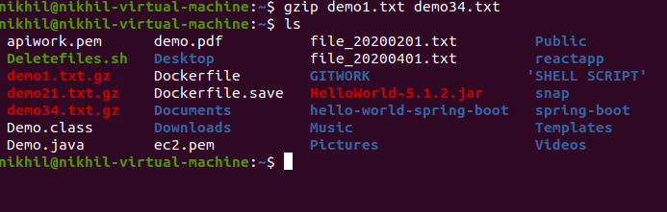

**34)gunzip:** It is used to gunzip the file

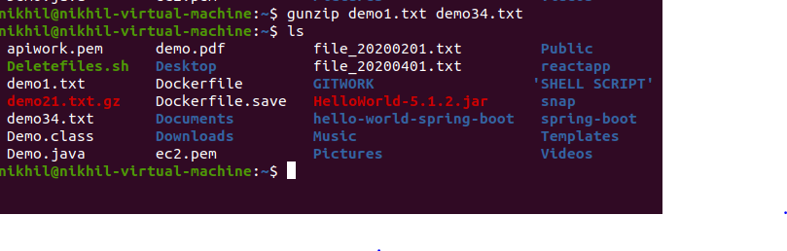

**35)find:** It is used to find the particular files

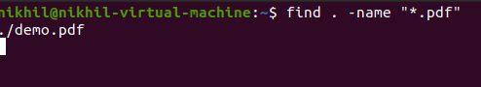

**36)locate**:It is used to search a file by file

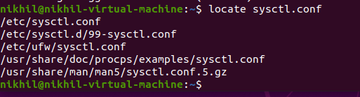

**37)data:** It is used to display the data and time



**38)cal :** It is used to display the calculator

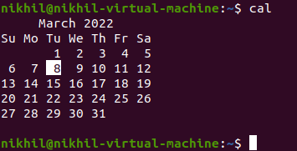

**39)sleep:** It is used to keep the system according to sec



40)time: It is used to time to execute a command

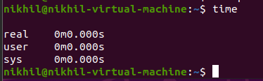

41)zcat : It is used to compressed the file.display the gzip file

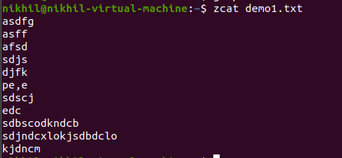

**42)df:** Display the disk space

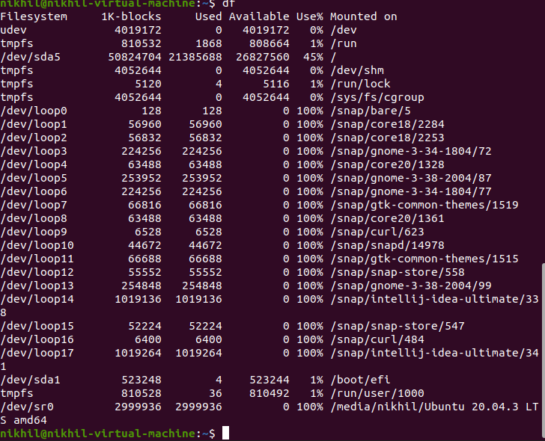

**43)mount:** It is used to connect the external device

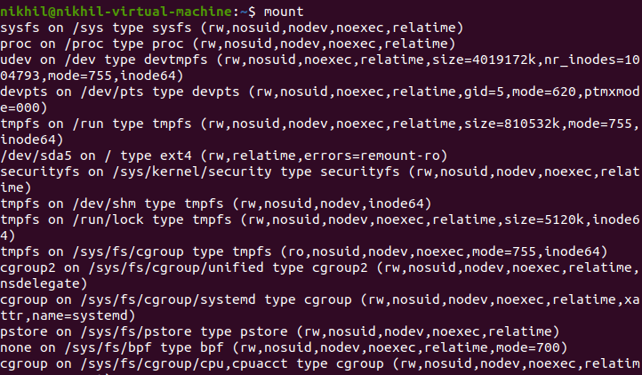

**44)exit:** It is used to exit from the terminal



**45)clear:** It is used to clear from the previous commands



**46)ip:** Linux ip command is an updated version of the ipconfig command

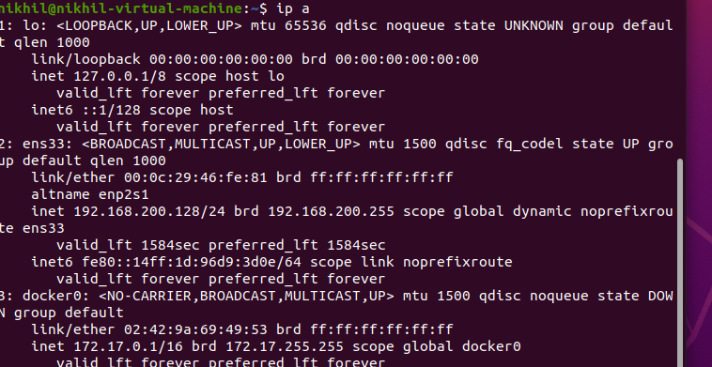

47)ssh:It is used to connect the instance to the server

ssh -i “nikhil_aws_example.pem” ec2-user@ec2-3-134-109-63.us-east-2.compute.amazonaws.com

**48)mail:**It is used to send emails from command line

1. mail -s "Subject" <recipient address>

**49)ping:** It is used to connectivity between two nodes

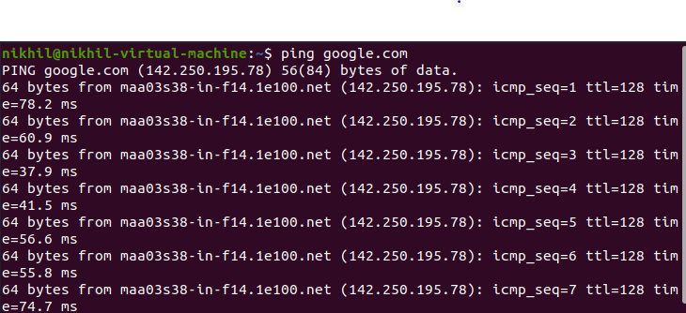

**50)host:** It is used to display the ip address of given domain name

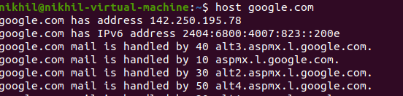

MAR - 09

1. create 2 empty file with these name sample1.txt and sample.txt
2. To Store "Hello world" in a file with echo command
3. compare 2 files
4. Scp a file into a server
5. Ssh into a server

1)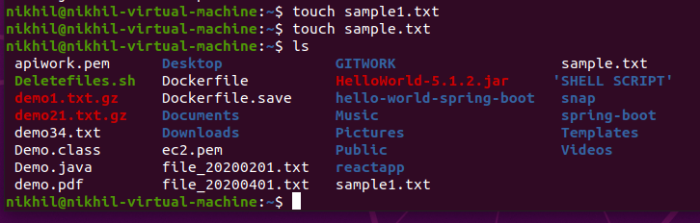

2)



3)

4)

scp<filename>user@<servername><location><ip><serverfilelocation>(where you store)

10.0.0.0

admin

test.txt

>>scp test.txt admin@amazon.com-ws-east

5)

ssh -i “nikhil_aws_example.pem” ec2-user@ec2-3-134-109-63.us-east-2.compute.amazonaws.com

ASSIGNMENT -1 MAR 9

1. Write a shell script to ask your name, program name and enrollment number and print it on the screen.
2. Write a shell script to find the smallest of three numbers
3. Write a shell script to create a file and mv the file into another location, and display the path of the file.

1)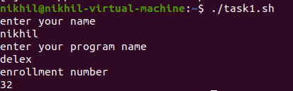

2)

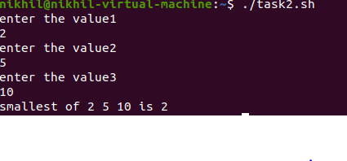

3)

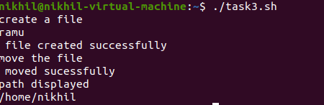

**ASSIGNMENT -2 MAR 10**

1. To write a shell script for downloading a file and saving it into a particular path,The download link and path are parameters.
2. Clone a react app and Write a script for run the react app

**4)**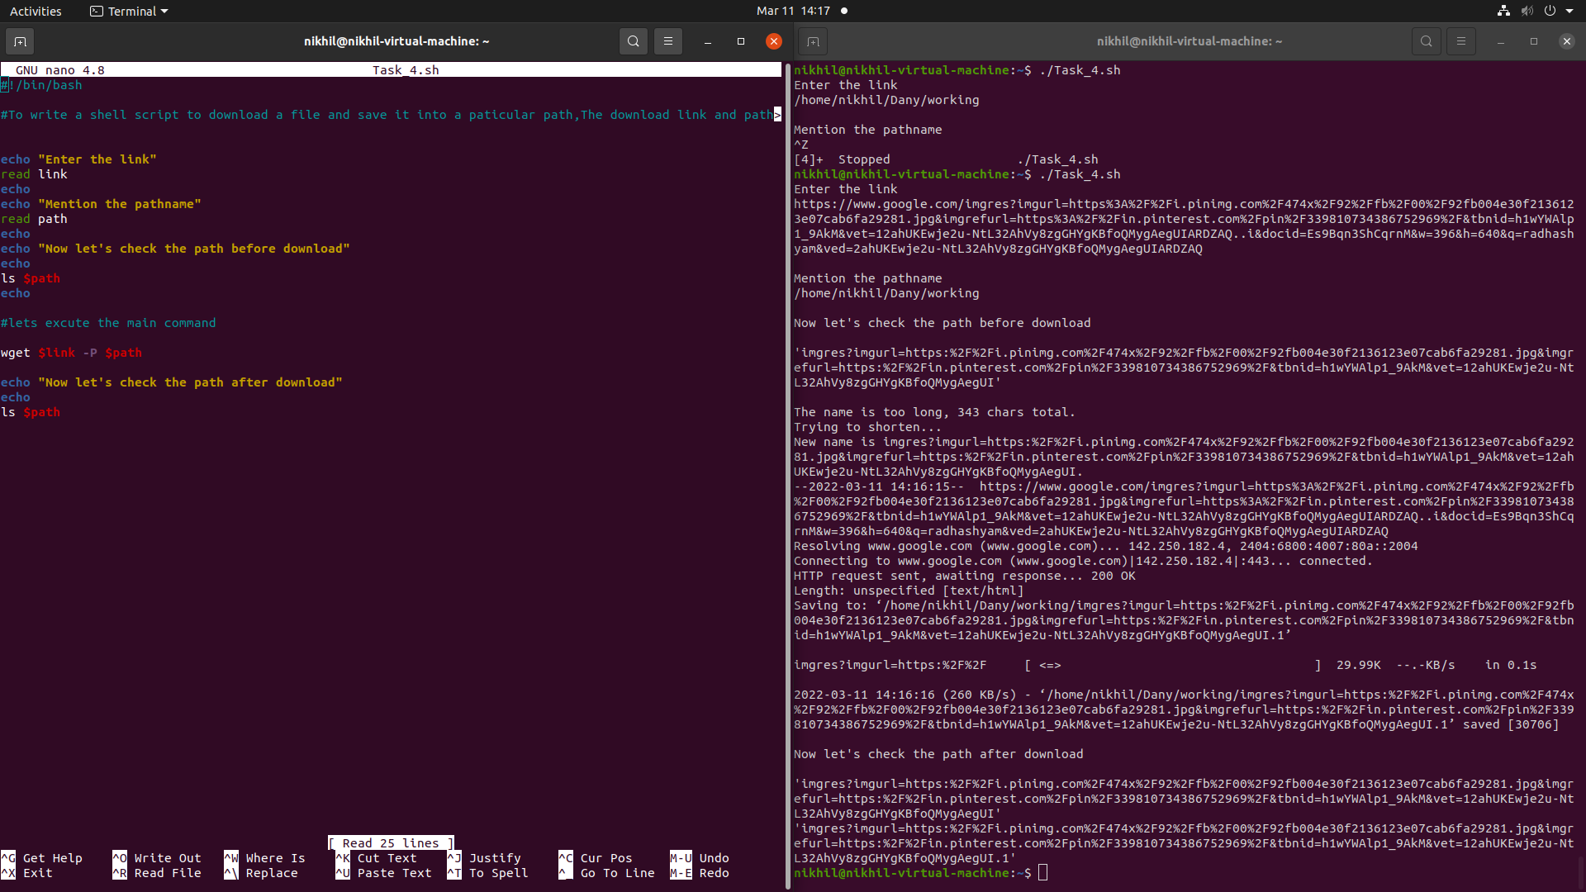

**5)**